Retail Dataset Portfolio Project

By Jackie Nguyen

Maximizing business revenue

Problem Statement:

Objective

The primary objective of this retail sales analysis project is to gain a deep understanding of customer behavior and interactions within the retail environment. Utilizing advanced data analytics techniques, we aim to identify key patterns and trends that can serve as actionable insights for strategic business decision-making.

Impact

These data-driven insights are designed to achieve two main goals:

Enhance Customer Engagement: By understanding customer behavior, we can tailor marketing strategies, optimize product placements, and improve overall customer experience.

Optimize Operational Efficiencies: Insights into sales trends and customer preferences will enable us to manage inventory more effectively, streamline operations, and ultimately increase profitability.

Methodology

For this analysis, the dataset has been aggregated and examined to identify trends that could further drive the company's profits. The dataset focuses on the following key columns:

* Description: The name of the item.
* Quantity: The number of items purchased in a single transaction.
* InvoiceDate: The date when the item was purchased.
* UnitPrice: The price of the individual item.
* CustomerID: A unique identifier for each customer.

Tools

The analysis leverages SQL for data aggregation and Tableau for data visualization. These tools enable us to format and interpret the data in a manner that is both insightful and actionable for business decision-making.

**Customer Spending Category**

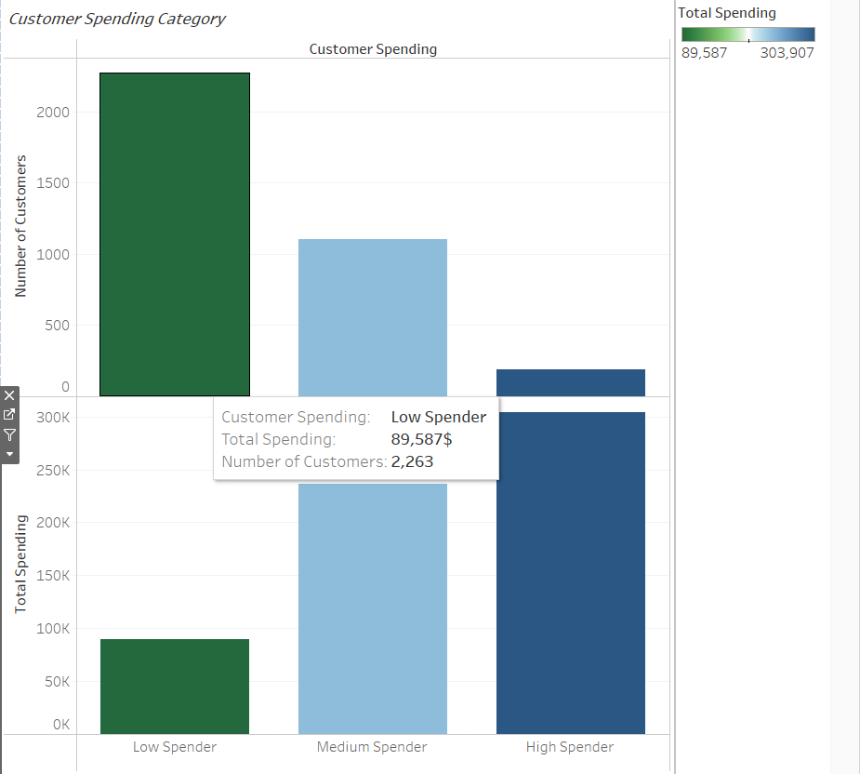

In our analysis, customers are segmented into three distinct categories based on their spending habits:

**Low Spenders:** Customers who have spent less than $100 in total.

**Medium Spenders:** Those whose total expenditure ranges between $100 and $500.

**High Spenders:** Customers who have spent more than $500.

Interestingly, while the dataset includes over 2,000 customers accounting for a total spend of approximately $89,687, a significant portion of the store's profits comes from a small subset of about 100 customers, who collectively contribute around $300,000 in revenue.

**Strategic Implications:**

**Customer Retention:** To retain these high-value customers, the store could implement a rewards points system or offer targeted discounts on items they frequently purchase.

**Pricing Strategy:** Alternatively, a tiered pricing strategy could be employed to incentivize higher spending. This could involve offering exclusive discounts to High Spenders, while slightly increasing prices for the Low and Medium Spender categories.

**Average Price per Item and Number of Purchases**

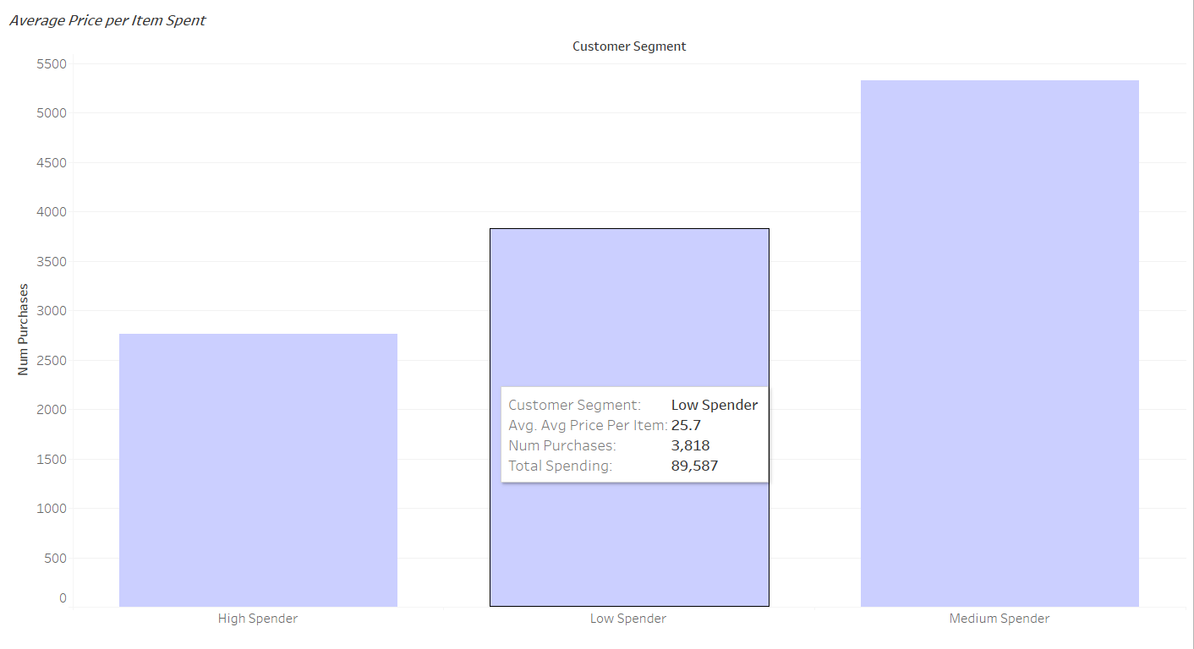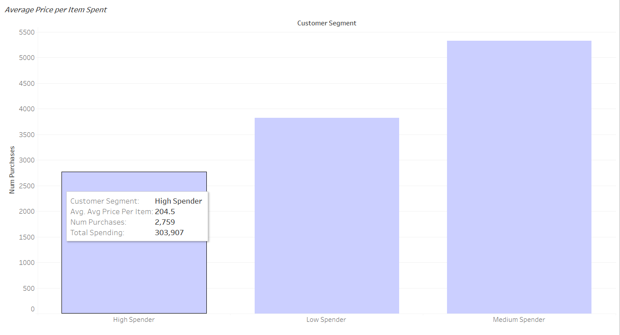

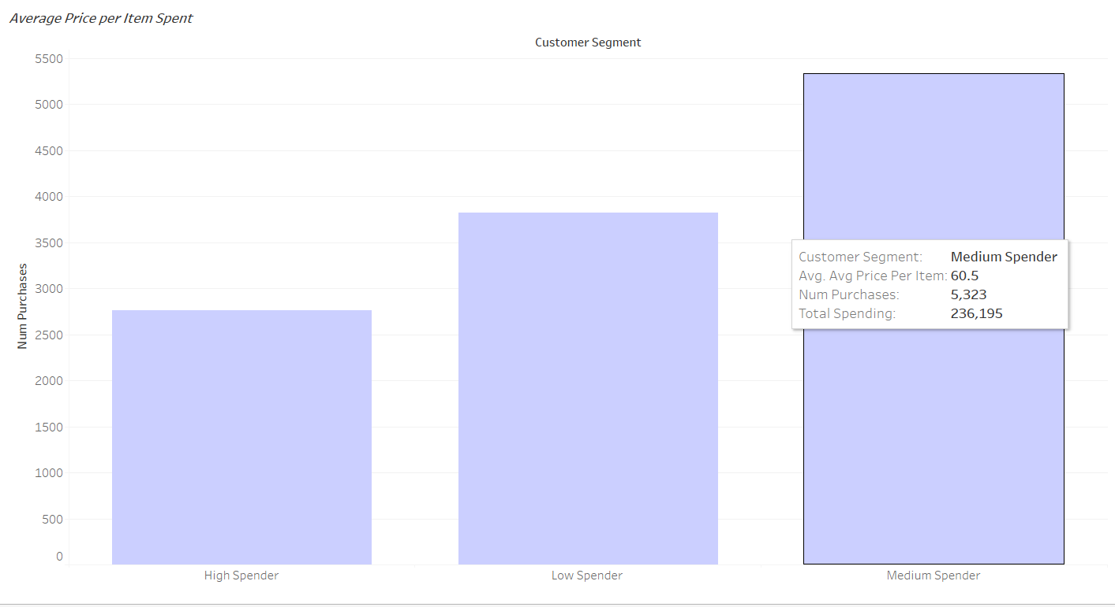

The correlation between the average item cost and the company's profits is generally consistent across customer segments. However, it's noteworthy that Medium Spenders tend to purchase the most items, making a substantial contribution to the company's revenue.

**Strategic Implications:**

**Rewards System:** Implementing a rewards system could further capitalize on this behavior. For instance, rewards could be allocated not just based on the total amount spent, but also on the number of items purchased or the frequency of store visits.

**Targeted Incentives:** Specifically, the store could introduce incentives for customers who may not necessarily buy high-cost items but are frequent shoppers. This would encourage repeat business and potentially elevate these customers to a higher spending category over time.

**Total Spending vs Number of Purchases**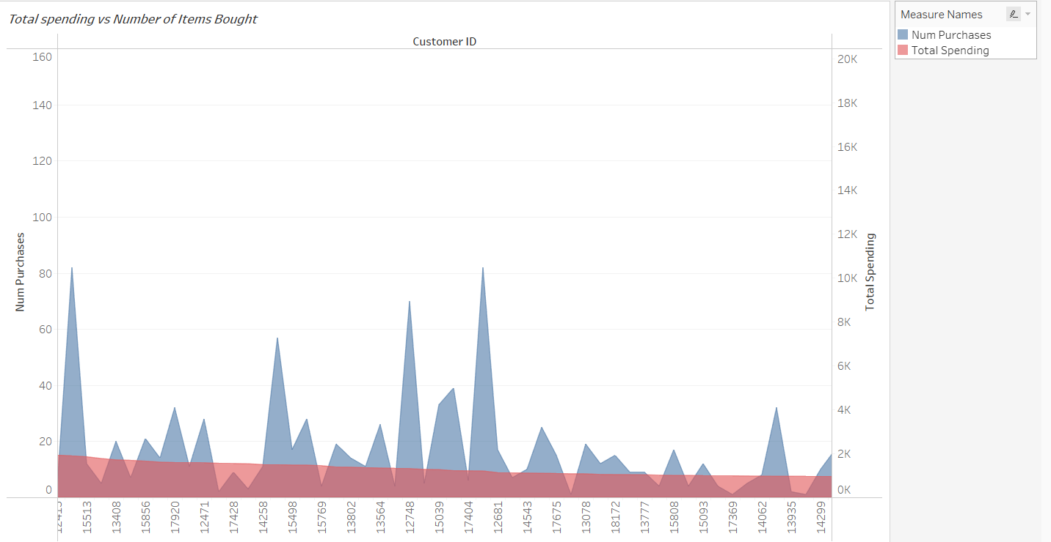

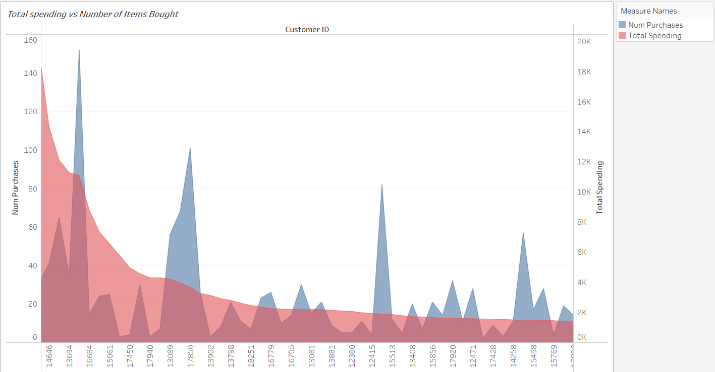

Based on the insights gleaned from our graph, the number of items purchased does not necessarily correlate with the total amount spent by customers. For instance:

One customer may have bought hundreds of towels priced at 25 cents each, accumulating a relatively low total expenditure.

Conversely, another customer might have made only two purchases, but if those are $1,000 chairs, the total spend would be significantly higher.

**Strategic Implications:**

**Product Mix Strategy:** This observation suggests the importance of a balanced product mix. Offering both high-value and low-cost items can cater to different customer preferences and spending behaviors.

**Targeted Marketing:** Tailoring marketing strategies to these distinct customer behaviors could optimize both sales volume and revenue. For example, bundling low-cost items could encourage higher spending among low-ticket buyers, while exclusive offers on high-value items could attract more affluent customers.

**What Tends to Be Bought and Bought Together**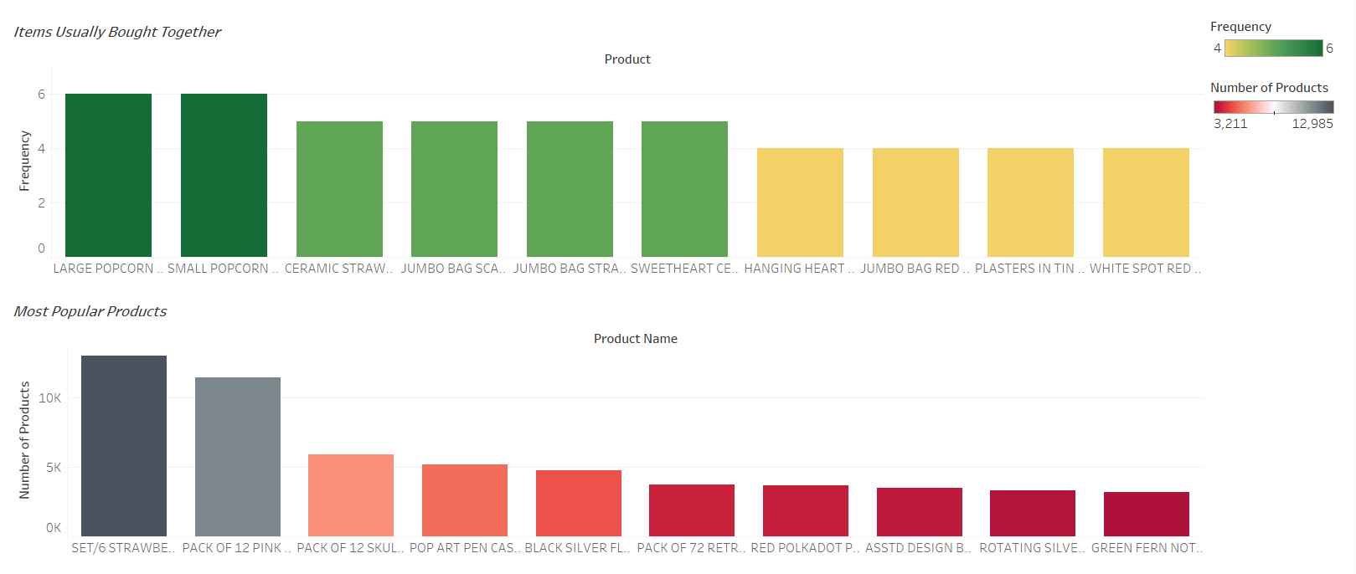

Our analysis also reveals interesting patterns in items that are commonly purchased together.

**Strategic Implications:**

**Promotional Bundling:** One effective way to capitalize on this behavior is through promotional bundling. For example, offering a "Buy One, Get the Second Item at a Discount" or even for free could incentivize customers to purchase these items together.

**Store Layout Optimization:** Additionally, placing such frequently bought items near each other can further encourage bundled purchases.

**Visibility and Accessibility:** For items that are popularly bought, strategic placement near the store's entrance or in easily visible locations can capture customer attention and drive sales.

**Per Month Sales and Number of Items Bought**

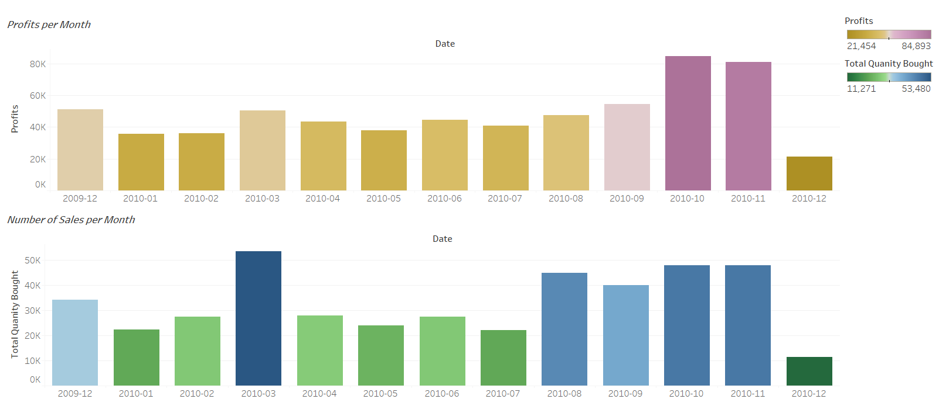

Our analysis indicates a noticeable seasonal trend in sales, with a significant uptick during the fall months. This surge can be attributed to events like Black Friday, back-to-school shopping, and Halloween. Interestingly, while sales generally decline in December after months of heightened activity, there are anomalies; for example, December 2010 saw a drop in sales, whereas December 2009 maintained a sales volume comparable to the fall season.

**Strategic Implications:**

**Seasonal Promotions:** To sustain customer engagement and sales momentum through the last quarter of the year, special fall promotions on commonly purchased items could be introduced.

**Rewards Program Enhancements:** Another strategy could involve enhancing the rewards program specifically for the fall and early winter months. This could include offering extra points or exclusive discounts to incentivize shopping during this period.

**Season Trends**  
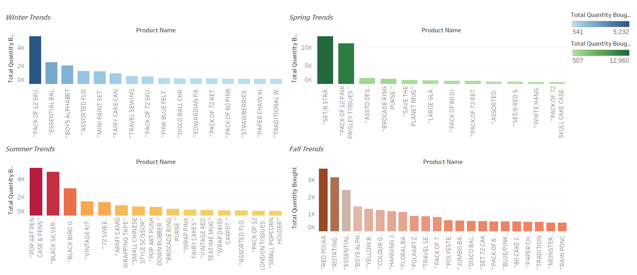

Building on strategies to boost sales of frequently purchased items, a multi-faceted approach can be employed that includes price adjustments, optimized store layout, and seasonal rewards programs.

**Strategic Implications:**

**Dynamic Pricing:** Implementing a dynamic pricing strategy for items that show seasonal demand can maximize revenue during peak periods and encourage sales during off-peak times.

**Location Optimization:** Adjusting the in-store placement of seasonal items can make them more accessible and visible, thereby driving sales.

**Seasonal Rewards:** Enhancing the customer rewards program to offer special incentives during specific seasons can further encourage purchases.

**Customer Experience:** Ultimately, these targeted strategies aim to not only increase sales but also improve the overall customer experience. A satisfied customer is more likely to engage in repeat business, thereby contributing to long-term revenue growth for the company.

**Conclusion**

Our comprehensive data analysis reveals several actionable insights to optimize sales and profitability for the retail store:

**Customer Segmentation:** Customers fall into three main categories—Low, Medium, and High Spenders. A small subset significantly contributes to overall revenue, highlighting the need for targeted retention strategies.

**Purchasing Behavior:** The number of items bought doesn't necessarily correlate with total spend, suggesting the importance of a balanced product mix and targeted marketing.

**Bundling and Store Layout:** Items frequently bought together present an opportunity for promotional bundling and optimized store placement to encourage higher sales.

**Seasonal Trends:** Sales peak during the fall but show variability in December. Seasonal promotions and enhanced rewards can sustain sales momentum through the year-end.

**Strategic Pricing and Rewards:** Dynamic pricing, location optimization, and seasonal rewards can be leveraged to boost sales and enhance customer experience.

By implementing these data-driven strategies, the retail store can not only increase short-term sales but also build stronger customer relationships for long-term revenue growth.